Scene 1:  Action: the camera shows me introducing the video  Voiceover: I say hi and introduce the concept of my video  Motion: I wave hello  Slide caption: the test on the screen states “Hi Everyone!” | 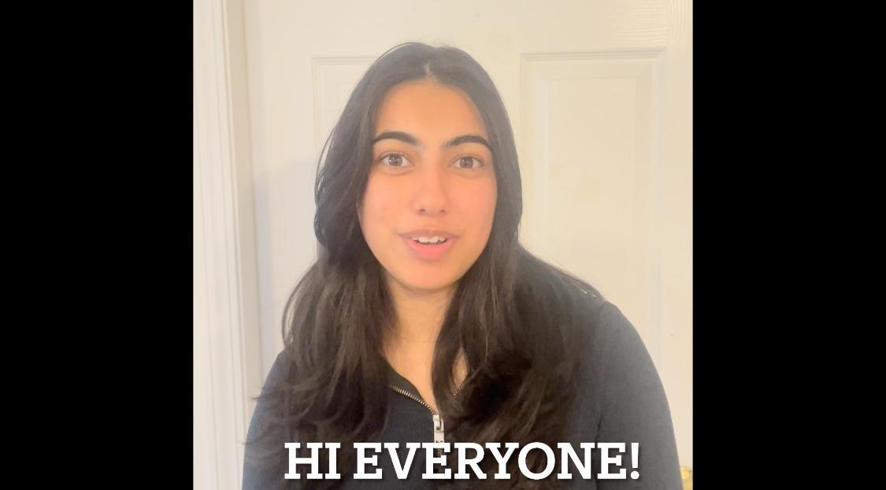
Scene 2:  Voiceover: Let’s get started!  Slide caption: the test on the screen states “Let’s get started” | 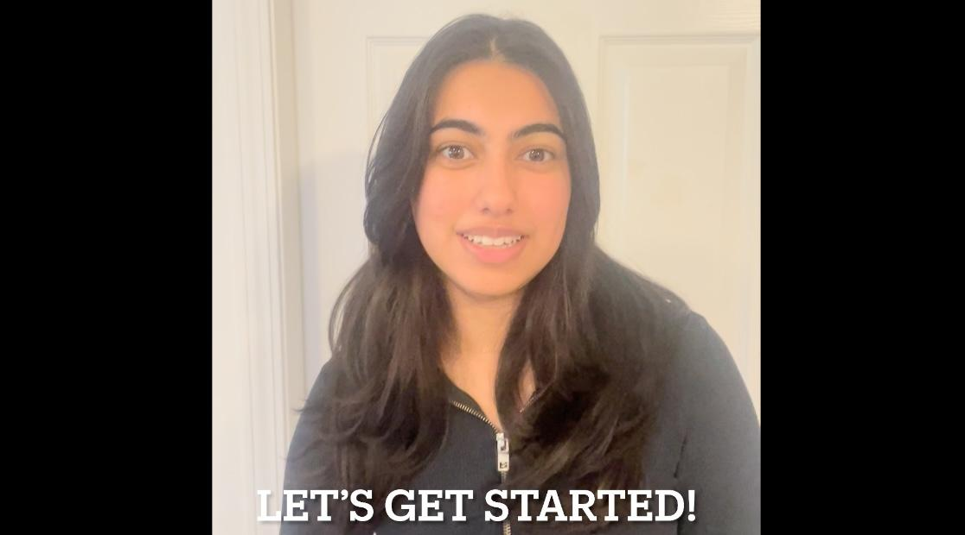
Scene 3:  Action: the camera shows me in the car demonstrating a right-hand turn signal  Voiceover: describes the arm motion of the right signal  Motion: My arm moves to the right-hand signal position  Slide caption: the test on the screen states “Right-hand turn signal” | 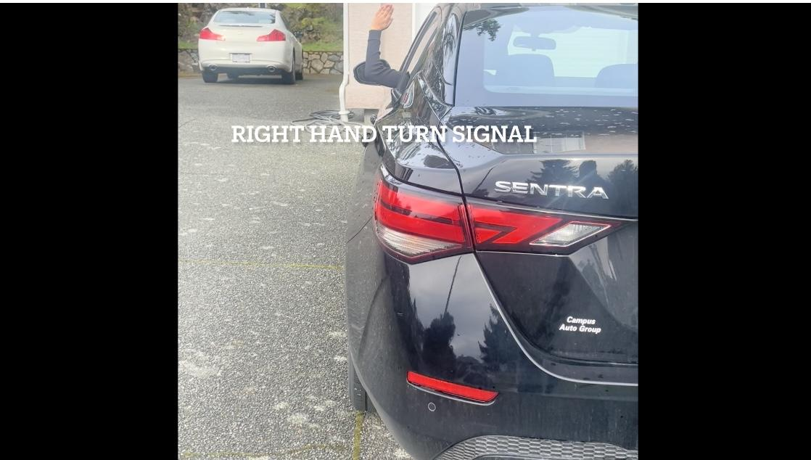
Scene 4:  Action: the camera shows me in the car repeating the demonstration of a right-hand turn signal  Voiceover: describes the arm motion of the right signal again  Motion: My arm moves to the right-hand signal position  Slide caption: the test on the screen states “Right hand turn signal” | 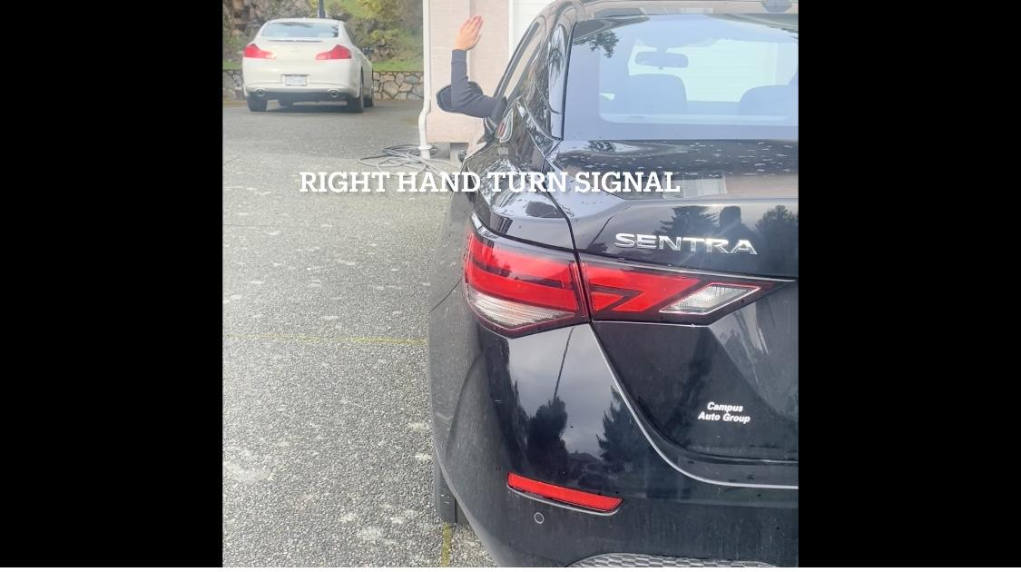
Scene 5:  Action: the camera shows me in the car demonstrating a left-hand turn signal  Voiceover: describes the arm motion of the left signal  Motion: My arm moves to the left-hand signal position  Slide caption: the test on the screen states “Left hand turn signal” | 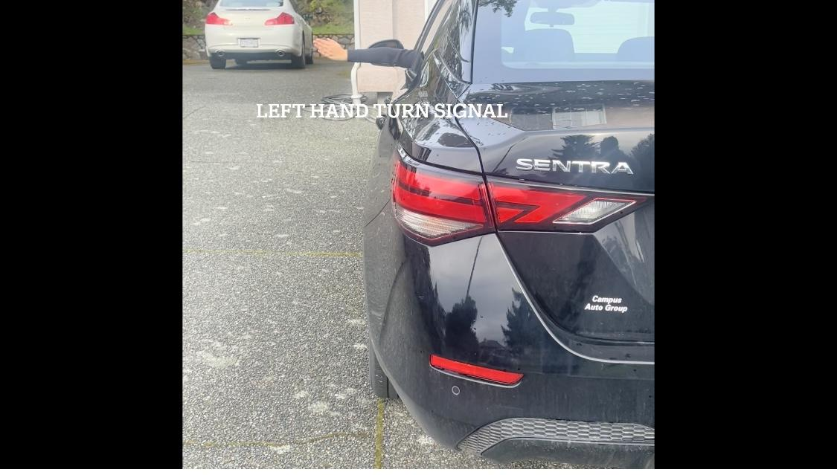
Scene 6:

Action: the camera shows me in the car repeating the demonstration of a left hand turn signal

Voiceover: describes the arm motion of the left signal again

Motion: My arm moves to the left-hand signal position

Slide caption: the test on the screen states “Left hand turn signal”

Scene 7:  Action: the camera shows me in the car demonstrating a stop-hand signal  Voiceover: describes the arm motion of the stop signal  Motion: My arm moves to the stop-hand signal position  Slide caption: the test on the screen states “Stop hand signal” | 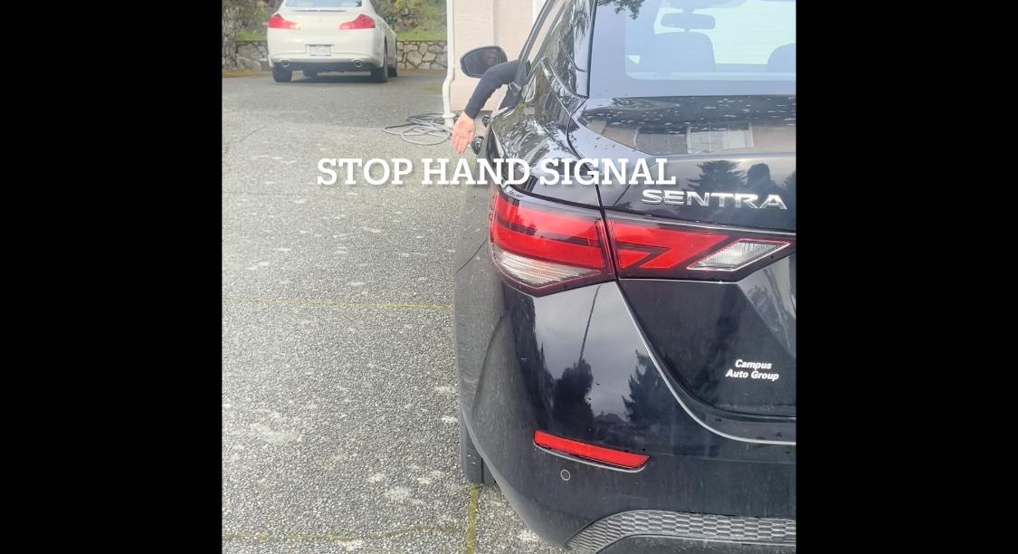
Scene 8:

Action: the camera shows me in the car repeating the demonstration of the stop hand signal

Voiceover: describes the arm motion of the stop signal again

Motion: My arm moves to the stop-hand signal position

Slide caption: the test on the screen states “Stop hand signal”

Scene 9:  Action: the camera shows me waving goodbye  Voiceover: I thank everyone for watching and say goodbye  Motion: I wave bye  Slide caption: the test on the screen states “Drive safe!” | 